RIHAM AHAMED ABDUL RAHEEM

HND COMPUTING IDM

TRAINING PROGRAM PROPOSAL

Contents

**MICROSOFT OFFICE PACKAGE** 1

Introduction 1

MS Office 1

**Microsoft Word** 1

**Microsoft Excel** 2

**Microsoft PowerPoint** 2

Important of Microsoft Office 2

Advantage of Microsoft Office 3

Disadvantage of Microsoft Office 3

**List of figure**

Figure 1: MS office pack 1

# **MICROSOFT OFFICE PACKAGE**

## Introduction

Our training program base on MS Office package which are Word, Excel and PowerPoint

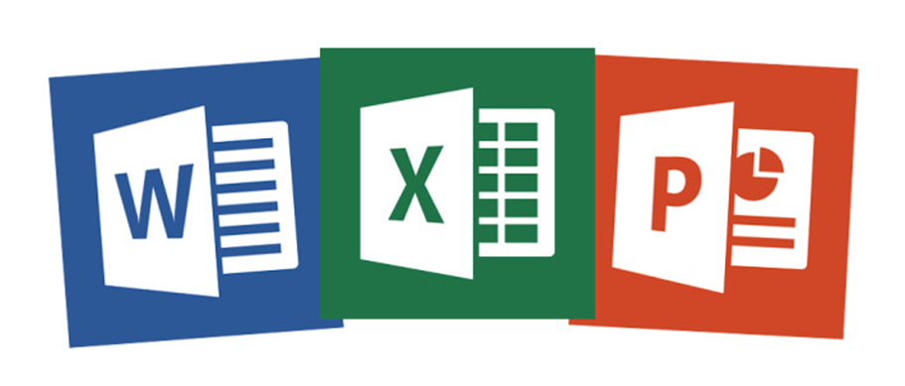This will help the O/L students.

Figure : MS office pack

## MS Office

Microsoft Office is a package of some high-end application which was developed by Microsoft Corporation. That includes Microsoft Word, PowerPoint, Excel, Access, Publisher, One Note and Outlook. All applications are very user-friendly and serve many purposes. The applications are compatible with other application in this package. The Microsoft office pack supports the Windows, Most Linux variants and Macintosh operating system. This bundle of applications is designed especially for office and business use. It was first released in 1990.

### **Microsoft Word**

This is word processor which lets a user to create official correspondence, reports and proposals etc. to a great extent. The powerful features of Word supports to creation of graphic based multi-column publications such as Newsletters, Fliers and webpages

### **Microsoft Excel**

Excel is used mostly for financed related activity. Excel is used for create new spread sheets where user can define custom formulas to calculate anything from a simple quarterly forecast to a full corporate yearly report makes Excel highly appealing. Excel is useful tool for scientific and statistical analysis.

### **Microsoft PowerPoint**

Power point is often used to create business presentation, but can also be used for informational and educational purposes. The PowerPoint can create presentations with comprised of slides which may contain text, images, audio clips, video clips, sound effects and animated transition. Power Point contains set of preloaded themes or templates to choose. It is also includes basic text editing and styling options.

## Important of Microsoft Office

* The Microsoft Office suite is an essential collection of desktop applications that includes Access for databases, PowerPoint for presentations, Excel for spreadsheets, Word for documents and much more. Microsoft Office is a Group of products developed by Microsoft Company that includes Word, Excel, Access, Publisher, PowerPoint.
* It remains the good standard in office applications.
* Microsoft Office is a required talent across offices worldwide.
* Microsoft Office has powerful and good ways to deliver your best work at your office and your business.
* Microsoft Office products help progress work efficiency with user responsive features.
* Microsoft office training program is planned for the people who want to grow their skills of using Microsoft Office.
* Microsoft is used by so various businesses, the services you have working on the software are directly transferable to new jobs and businesses.
* You can connect and work together more successfully with the Microsoft tools.

## Advantage of Microsoft Office

* Simple and direct features that allow you to reach the end result speedily with comfort make MS Office one of the most used software in the world.
* As the features in MS Office is continuously improved with each release.
* Wide range of operator guides and support files available online and offline, there is no way you can go erroneous with MS office.
* Diverse language care system with comprehensive spellings and grammar checks, dictionary and thesaurus available in over 50 languages in there.
* Many simple short cuts and buttons being counted in the interface.
* MS office applications are simple to use, learn and maintain
* Easily correct any mistakes
* Mail merges from a database so that you can easily send out letters to multiple people at a time.
* Copies can easily be made

## Disadvantage of Microsoft Office

* **Too many features**
* **Very expensive**
* **Typing is terrible when there is a black out or laptops batteries is death, the plagiarism is relaxed to do because it is very easy to just copy and paste.**
* **Some symbols aren’t simply reachable which makes the typing in changed languages that custom a different alphabet is problematic and some complex mathematical equations would be cooler to hand write.**
* **While sharing and teamwork of the documents within a small group, only one person can make modifications at any given time, the shared documents cannot be corrected in real time and start again numbering & bullets is difficult.**
* Data can sometime be lost due to data corruption.